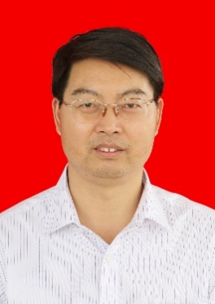
Research Interests:
Electronic ceramics Energy-storage ceramics
Luminescent glass-ceramics

Phone: 13977310372
School: Guilin University of Electronic Technology
Technology
Political appearance: members
Phone: 13188888888
E-mail: 123456@qq.com
Education: PhD
Phone: 13188888888
E-mail: 123456@qq.com
CHEN GUOHUA Xiaolin
E-mail: cgh1682002@163.com
.com
Papers
Education background
Experience
Professional skill
1.
2.
3.
2002.9-2021.6

2009.10-2010.12
Sheffield University / Visiting scholar
work description:
- Mainly responsible for Learning English courses and Research and development of microwave dielectric ceramics
- Learning operation skills of SEM
Guilin University of Electronic Technology/ Professional teacher
work description:
- Teaching undergraduate courses of Fundamentals of Inorganic Materials Science and Scientific and technological literature retrieval
- Teaching graduate course of Material structure and properties
- Guiding graduation project/thesis
- Guiding Master Degree Candidate
Education background
2002.5-present

Experience
- Proficient in Ceramic Engineering, Glass Science and Process;
- Analysis of structure, microstructure by using SEM, XRD, IR and Raman spectra;
- Analysis of dielectric properties by precision impedance spectrum, dielectric temperature spectrum

Ph.D., Central South University, 2006, Material Physics and Chemistry
M.S., East China University of Science and Technology,1991, Inorganic nonmetallic material
B.S., China University of Science and Technology,1991, Inorganic nonmetallic material

- Preparation, crystallization kinetics and microwave dielectric properties of CaO-ZnO- B2O3-P2O5-TiO2 glass-ceramics, Ceramics International, 2019,45: 8233-8237
- Optical properties and energy transfer in Tb3+/Sm3+ co-doped Na2O-CaO-P2O5 -B2O3-ZrO2 glasses, Journal of Alloys and Compounds, 2017, 692:346-350
- Dielectric characterization and energy-storage performance of lead-free niobate glass–ceramics added with La2O3, Ceramics International 2016,42:1827-1832
- Effect of crystallization temperature on the dielectric property and energy density of SrO–BaO–Nb2O5–B2O3 glass–ceramics, Journal of Non-Crystalline Solids,2015, 410: 96-99
- Crystallization kinetics and dielectric characterization of CeO2-added BaO–SrO–Nb2O5 –B2O3 –SiO2 glass-ceramics, Ceramics International, 2013,39: 5553-5559
- Microwave Dielectric Properties of Ca4La2Ti5-x(Mg1/3Nb2/3)xO17 Ceramics, Journal of the American Ceramic Society, 2012,95,1394-13972

Projects

1. Study on design preparation structure and optical thermometry performance modulation of transparent glass ceramics containing fluorapatite nanocrystals, China National Natural Science Fund Committee
2. Study on control preparation and performance regulation of rare earth-doped fluorescent transparent glass ceramics in wide temperature area, Guangxi Science and Technology Department, China

Awards
1. Guangxi Science and Technology Progress Award, 2010
2. Guangxi Natural Science Award, 2015
3. Guangxi Teaching Achievement Award, 2017, 2019

